**Academic year 2019-2020**

**Department of Computer science and engineering**

**KARNATAKA LAW SOCIETY’S**

**GOGTE INSTITUTE OF TECHNOLOGY**

**UDYAMBAG, BELAGAVI-590008**



**Software Development Lab**

**Software Requirement Specification Document**

**On**

**”Crime Reporting Android Application”**

**Semester: 6th**

Lakshya Tripathi 2GI17CS056

Ashish Joshi 2GI17CS022

Sucheta Kulkarni 2GI17CS054

**Table of Content**

1. **Introduction**
   1. Purpose
   2. Objective
   3. References
   4. Technologies to be Used
2. **Overall Description**
   1. Assumption and Dependencies
   2. Requirement Analysis
   3. Use case model survey
   4. Class Diagram
   5. Database design
   6. State Diagram
   7. Activity Diagram
   8. Sequence Diagram
   9. Data Flow Diagram

**Introduction**

**Purpose:**

In today’s era mobile technology can be used in many other fields and application such as Gaming, Maps, E -mail, Messaging, Photography and so on. One such area is crime reporting and storing criminal data record. The proposed mobile application can be used to report minor crimes, offer anonymous tips to police, stay updated on crimes in progress, file missing person reports or check on stolen property. As the criminal data is not available remotely there is a communication gap between the police officials investigating any case. The application will provide the general users with the facilities like reporting any incident.

**Objectives:**

The Objective of Crime Reporting System is to develop an android application using which people can report crime via their smart phone . It provides the facility of uploading images of crime scenes to ensure that police may take action immediately. It also supplies the advice of missing persons, most wanted criminals and security tips for the awareness of people.

**References:**

1. Roger. S. Pressman, Software Engineering – A Practitioners Approach, Tata-McGraw Hill 4th Edition

2. Ali Bahrami, Object Oriented Systems Development, McGraw Hill, 1999

3. Mark Murphy, The Busy Coder's Guide to Advanced Android Development

4. IEEE SRS format

5. [https://developer.android.com](https://developer.android.com/)

6. [https://www.materialpalette.com](https://www.materialpalette.com/)

**1.5 Technologies to be used**

1. Operating System : fedora version 31

2. Visual Modelling : Visual Paradigm, Umbrello UML Modeller

3.Designing : Adobe XD

4. Integrated Development Environment : Android Studio

5. Web server : Google firebase

6. Database- Google firebase Realtime database

7.Front end: XML

8. Backend: Java

**Overall Description:**

**2.1 Assumptions, Dependencies and Constraints**

1. Project will be developed and deployed under Linux platform.

2. The user interface will be android based.

3. The user must have the knowledge of using the Internet.

4. The user must register to the Application.

5. Username and password will be used for Identification and authentication.

9. There must be clear and measurable information while reporting the

incidents .

10. Clear measurable deliverables with measurements specified.

11. The application will only take minor complaint.

12. The application package must be installed on the client smart phone.

13. Project phase will be declared as complete only after it is approved by authority.

**2.2 Requirement Specification:**

Software Requirements: Windows 10,Fedora,Android SDK, Adobe XD, Visual Paradigm, Umbrello UML development kit

Hardware Components: • Hard Disk – 5 GB • Memory – 1GB RAM

**FUNCTIONAL REQUIREMENTS:**

1. LOGIN AND LOGOUT The citizens who wish to use the application will have to login into the app. If the user isn’t registered, then he can only view the Missing persons reported around his area but will not be able to file any report unless they are logged in.
2. LODGE A FIR FOR LOST SIM The citizen can file for a FIR for the lost sim cards and phone online through the application and the digital copy of the report will be shared between the user and the police.
3. REGISTRATION OF COMPLAINT Citizens can register their complaints with police and then based on the evidence, facts and following investigation, police shall take the complaint forward. The Registration module acts as an interface between the police and citizens and it eases the approach, interaction and information exchange between police and complainants.
4. MISSISING PERSON REPORT Citizens will be able to file report of missing person directly with the app along with several information like image of the missing person and personal information. The data will be shared with the relevant police station and the status will be updated.
5. STOLEN VEHICLE REPORT Citizens will be able to file report of missing vehicle directly with the app along with several information like type of the vehicle ,registration no. , chassis no. The data will be shared with the relevant police station and the status will be updated.
6. FIND NEAREST POLICE STATION The citizens will be able to locate the nearest police station from their location. Using a MAP and get the directions using third party API’s.
7. SOS SIGNAL The application will also have an emergency SOS option that the Citizens can send to the police authorities in case of a severe emergency.

**NON FUNCTIONAL REQUIREMENTS**

• The non-functional requirements specify the qualitative attributes such as user-friendliness and performance of the system that are critical for the increased user-acceptance of the application.

1. SYSTEM AVAILABLITY

a. The System must be available to users: i.e. on <all weekdays/363 days per year> j. from <00:00> to <23:45>;

b. The planned downtime for the System must not exceed 12 hours per rolling three-month period. The System is considered to be down if any user is unable to perform any normal System function and if this failure is attributed to any component of the System other than the workstation.

c. In the event of any software or hardware failure, it must be possible to restore the System (with inline synchronization) within no more than 03 hours.

1. PERFORMANCE AND SCALABILITY

a. The System must provide adequate response times for commonly performed functions under both standard and peak conditions like SOS Functionality.

b. The System must be able to perform a simple search within 5-8 seconds and a advanced search (multiple search criteria) within 10-15 seconds regardless of the storage capacity or number of cases in the system. In this context, performing a search means returning a result list. It does not include retrieving the records themselves.

1. USABLITY

a. The user interfaces should be designed to make them user-intuitive.

b. Making navigation self-descriptive: Navigation should be designed to help users understand where they are, where they have been and where they can go next c. Minimizing navigation effort: The number of navigation steps needed to reach a certain piece of content should be minimized as long as different mental models, navigation strategies and tasks of the user are taken into account.

d. Minimizing user errors: Potential user errors as well as the effort needed to recover from errors should be minimized.

e. Making user interfaces robust: User interfaces should be designed to be as robust as possible in the face of changing technology. This encompasses being able to present content containing newer technologies by older user agents as well as designing content to be usable with future technologies.

f. Text quality: The quality of textual content with respect to spelling and grammar should be sufficient so as not to impede readability.

g. Linking back to the home page or landmark pages: Each page should contain a link leading to the home page of the application or to a landmark page that is easy to recognize for the user.

1. SECURITY

a. Database cannot be altered by any user apart from the administrator.

b. Privacy of the user should be maintained.

**Use case Diagram:**

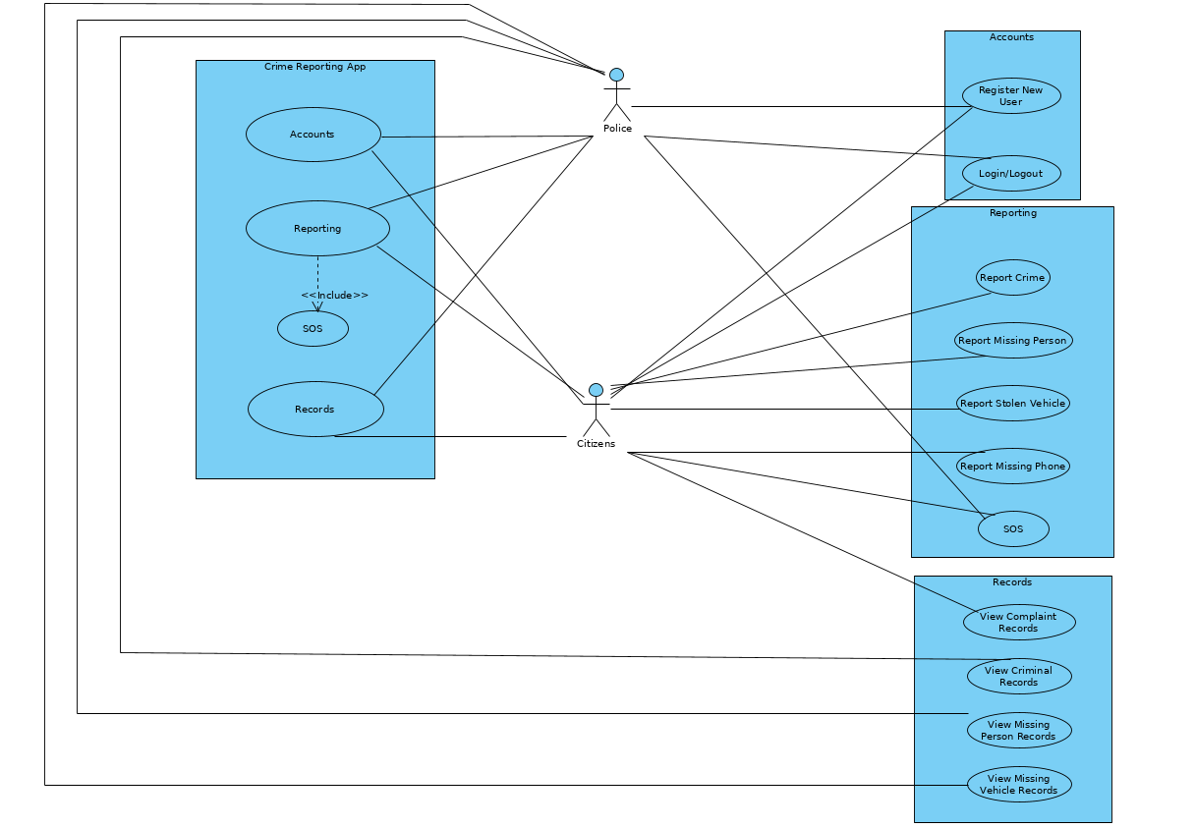

**Actors**

1. Police
2. Citizen

**Functionality for actors:**

**Citizen**

1. Register
2. Login
3. Add Complaint
   1. Report Crime
   2. Report Stolen Vehicle
   3. Report Stolen Phone
4. SOS
5. Missing Person Report

**Police**

1. View Complaints
2. View Missing Person Records
3. SOS

Activity Diagram:

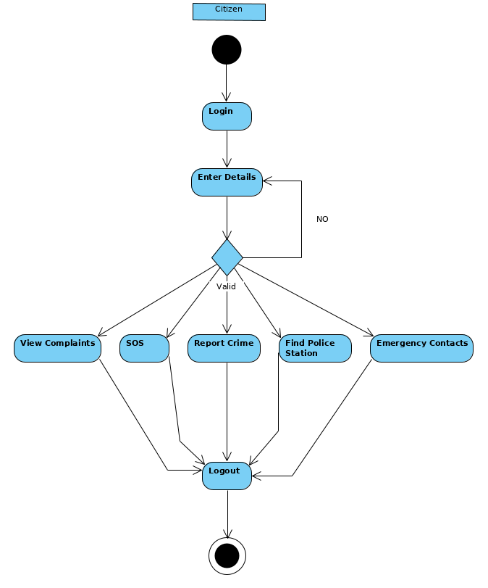

**Sequence Diagram:**

**Login/Logout:**

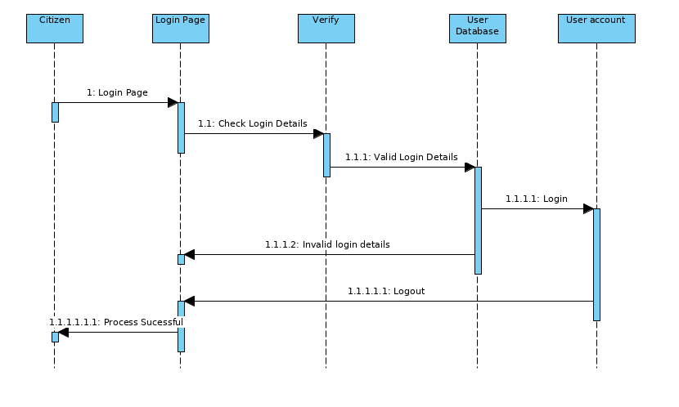

**Reporting:**

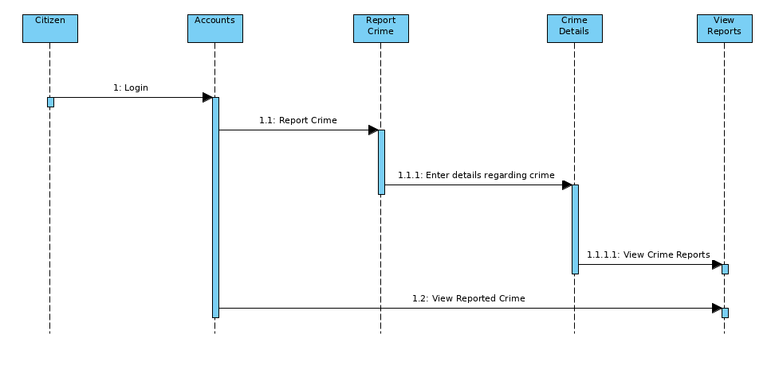

**Data Flow Diagram:**

**Level 0 DFD:**

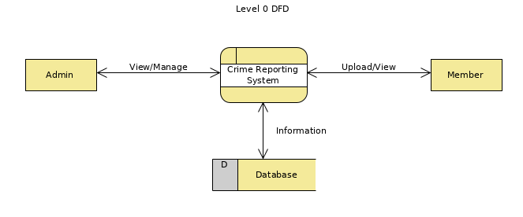

**Level 1 DFD:**

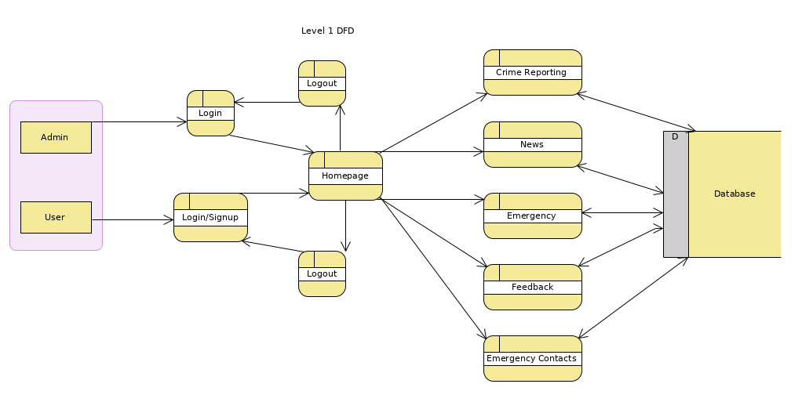

**Level 2 DFD (Citizen):**

